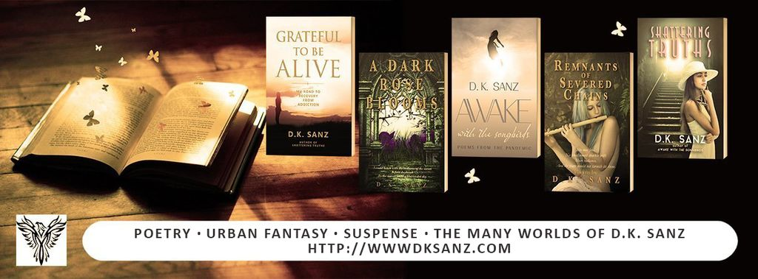

BOOKS

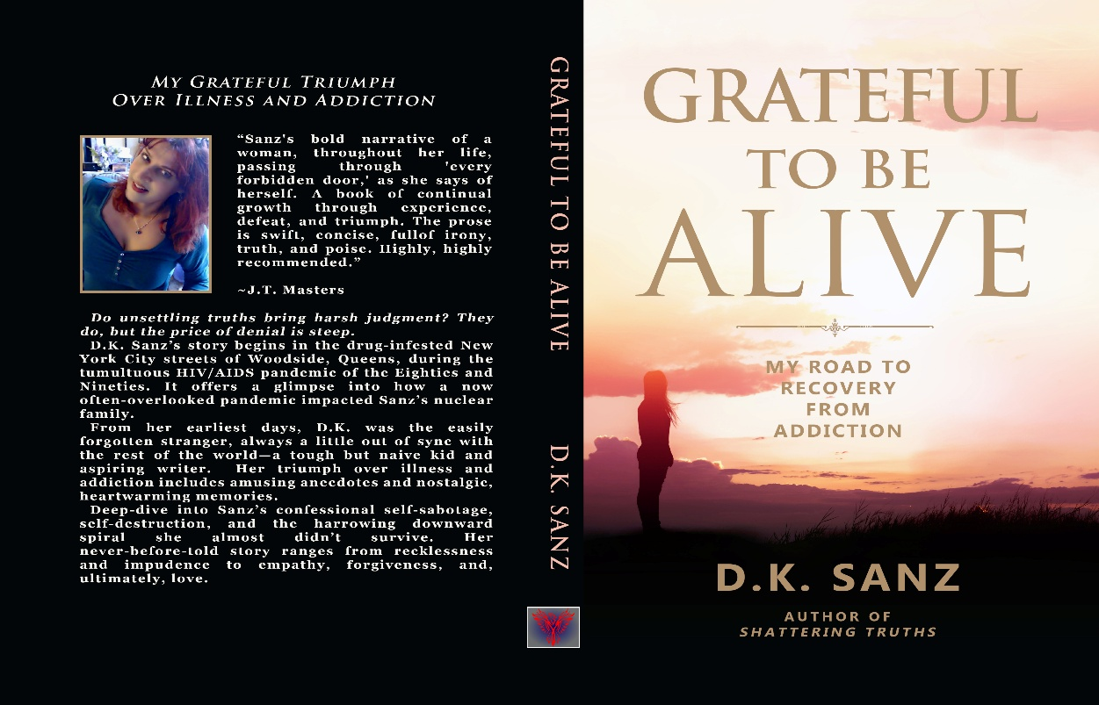

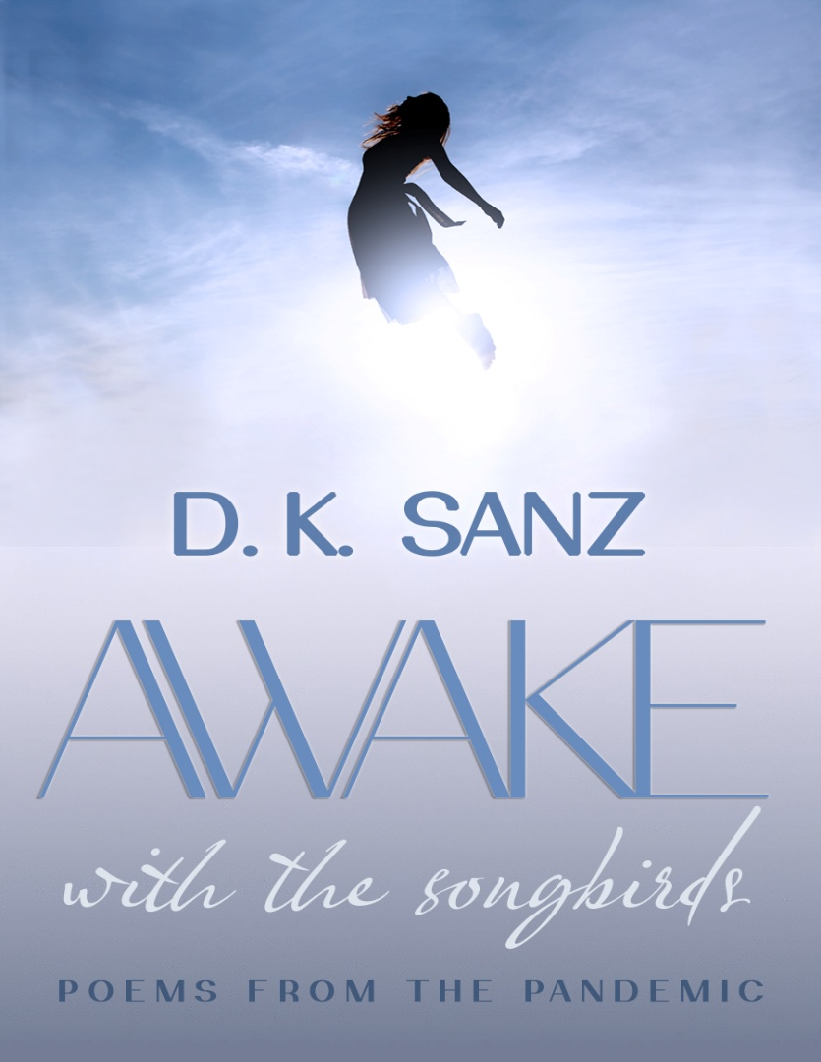

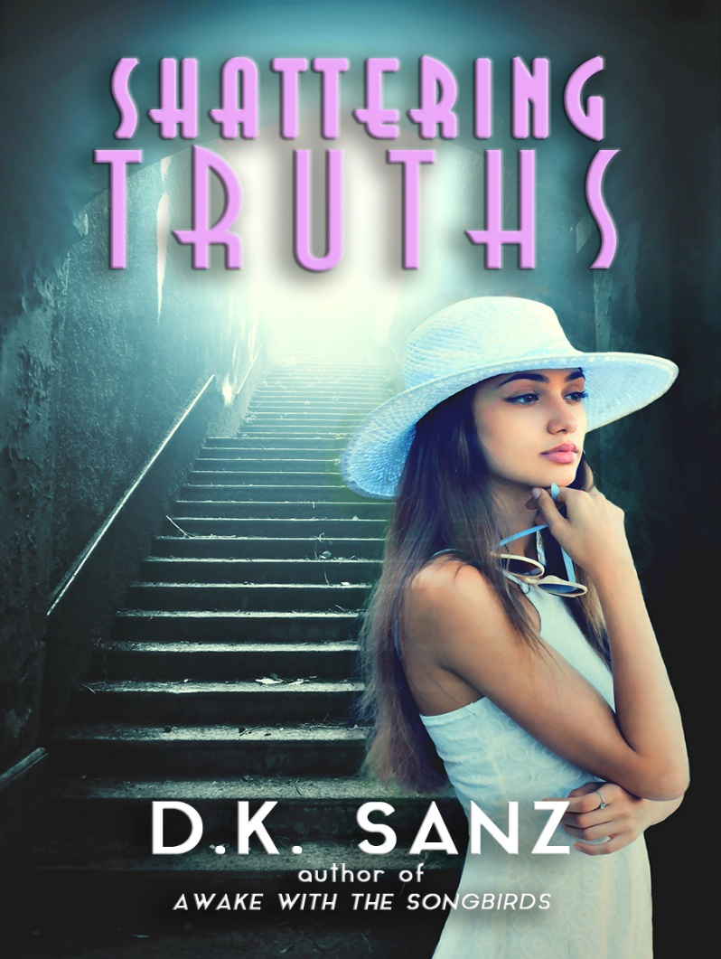

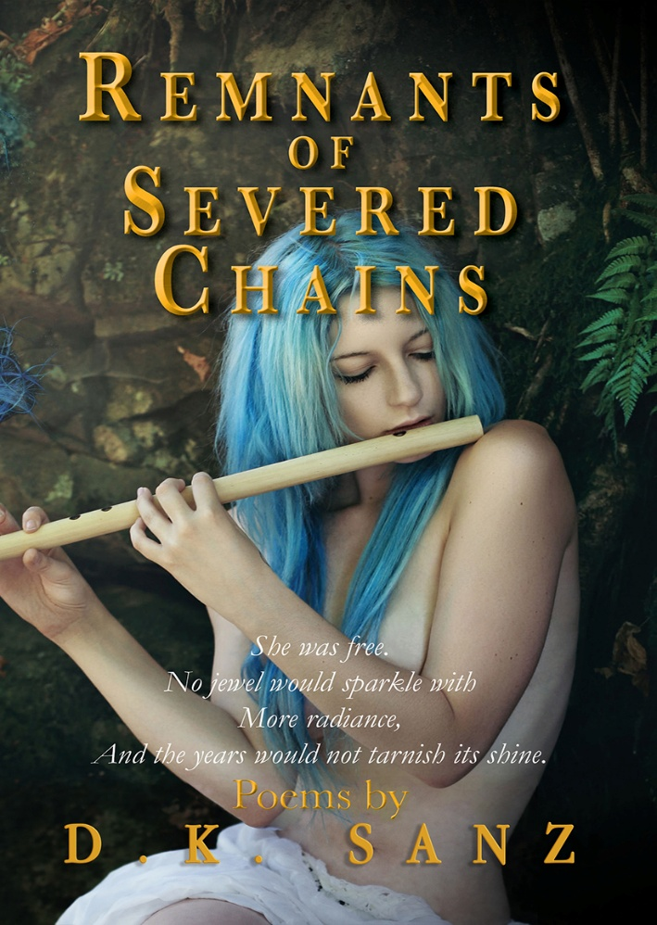

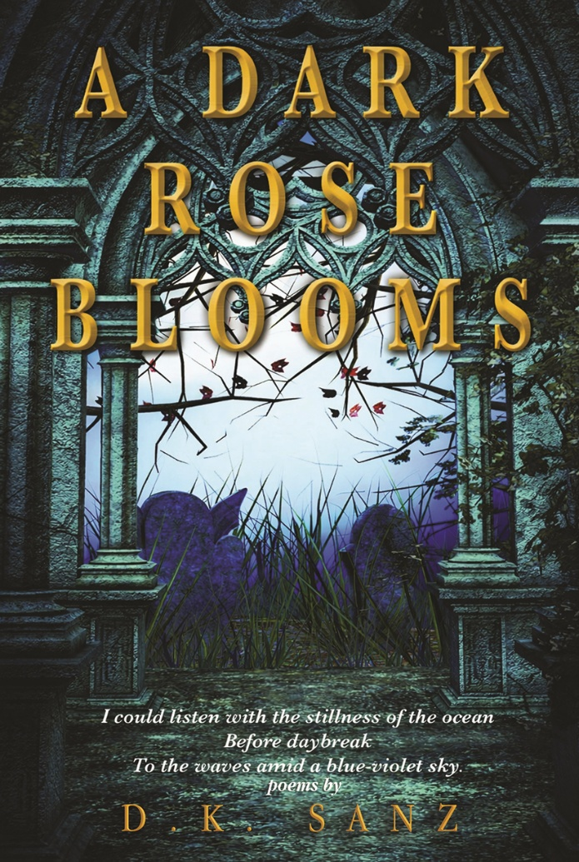

AUTHOR PHOTO

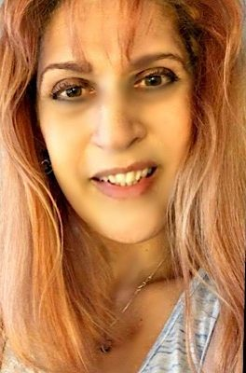

AUTHOR BIOS

LENGTHY BIO

D.K. Sanz is an author of literary fiction, poetry, new adult fiction, and dark fantasy with gothic themes. Her writing often explores complex family dynamics, while at the same time offering readers an escape from the mundane. It frequently delves into the complexities of relationships and tackles difficult and taboo topics, including addressing the unique challenges of mental health and addiction.
“As a writer, I am endlessly fascinated by human behavior,” she explains, “and my work blends this fascination with the challenges of navigating life through internal conflicts, social expectations, hidden truths, and the impact of generational trauma and confronting one’s past.”
Her consistent goal as a writer is to provide a deeper understanding of the human experience. She feels writing is cathartic and is forthcoming about her many years of recovery, as well as being a trauma survivor. Throughout her journeys, she expressed her thoughts through poetry, embracing every challenge to triumph over adversity. In her conviction that learning, growing, healing, and evolving is a never-ending process, she remains as grateful for the dark days as she is for every flicker of hope and light. She considers herself a cheerleader for those trudging on against all odds in the hopes of living their dreams.
Sanz has been writing since she was eight years old, starting with short stories and fairy tales and later moving on to poetry in her adolescence. She wrote her first novel at sixteen while working as an editor for her high school newspaper, and went on to complete two more novels at the ages of nineteen and twenty-five.
She is the author of the coming-of-age novel Shattering Truths, as well as the poetry collections A Dark Rose Blooms, Remnants of Severed Chains, and Awake with the Songbirds: Poems from the Pandemic, previously published under the name Kyrian Lyndon, and the autobiographical memoir Grateful to Be Alive: My Road to Recovery from Addiction.
Sanz is also an avid reader of psychological thrillers and horror. She enjoys music, art, history, food, fitness, video games, and cooking.
Born and raised in Woodside, Queens, New York, Sanz is the middle of three daughters born to immigrants—her father from Campochiaro, Italy, and her mother from Havana, Cuba. She currently resides in New York.
MEDIUM BIO
D.K. Sanz is an author of literary fiction, poetry, new adult fiction, and dark fantasy with gothic themes. Her writing often explores complex family dynamics, while at the same time offering readers an escape from the mundane. It frequently delves into the complexities of relationships and tackles difficult and taboo topics, including addressing the unique challenges of mental health and addiction.
“As a writer, I am endlessly fascinated by human behavior,” she explains, “and my work blends this fascination with the challenges of navigating life through internal conflicts, social expectations, hidden truths, and the impact of generational trauma and confronting one’s past.”
Her consistent goal as a writer is to provide a deeper understanding of the human experience. She feels writing is cathartic and is forthcoming about her many years of recovery, as well as being a trauma survivor. Throughout her journeys, she expressed her thoughts through poetry, embracing every challenge to triumph over adversity. In her conviction that learning, growing, healing, and evolving is a never-ending process, she remains as grateful for the dark days as she is for every flicker of hope and light. She considers herself a cheerleader for those trudging on against all odds in the hopes of living their dreams.
She is the author of the coming-of-age novel Shattering Truths, as well as the poetry collections A Dark Rose Blooms, Remnants of Severed Chains, and Awake with the Songbirds: Poems from the Pandemic, previously published under the name Kyrian Lyndon, and the autobiographical memoir Grateful to Be Alive: My Road to Recovery from Addiction.
Sanz is also an avid reader of psychological thrillers and horror. She enjoys music, art, history, food, fitness, video games, and cooking.
Born and raised in Woodside, Queens, New York, Sanz is the middle of three daughters born to immigrants—her father from Campochiaro, Italy, and her mother from Havana, Cuba. She currently resides in New York.

SHORT BIO

D.K. Sanz is an author of literary fiction, poetry, new adult fiction, and dark fantasy with gothic themes. Her writing often explores complex family dynamics, while at the same time offering readers an escape from the mundane. It frequently delves into the complexities of relationships and tackles difficult and taboo topics, including addressing the unique challenges of mental health and addiction.
She is the author of the coming-of-age novel Shattering Truths, as well as the poetry collections A Dark Rose Blooms, Remnants of Severed Chains, and Awake with the Songbirds: Poems from the Pandemic, previously published under the name Kyrian Lyndon, and the autobiographical memoir Grateful to Be Alive: My Road to Recovery from Addiction.
Sanz is also an avid reader of psychological thrillers and horror. She enjoys music, art, history, food, fitness, video games, and cooking.
Born and raised in Woodside, Queens, New York, Sanz is the middle of three daughters born to immigrants—her father from Campochiaro, Italy, and her mother from Havana, Cuba. She currently resides in New York.

MINI BIO
D.K. Sanz is an author of literary fiction, poetry, new adult fiction, and dark fantasy with gothic themes. Her writing often explores complex family dynamics, while at the same time offering readers an escape from the mundane. It frequently delves into the complexities of relationships and tackles difficult and taboo topics, including addressing the unique challenges of mental health and addiction.
She is the author of the coming-of-age novel Shattering Truths, as well as the poetry collections A Dark Rose Blooms, Remnants of Severed Chains, and Awake with the Songbirds: Poems from the Pandemic, previously published under the name Kyrian Lyndon, and the autobiographical memoir Grateful to Be Alive: My Road to Recovery from Addiction.
Sanz is also an avid reader of psychological thrillers and horror. She enjoys music, art, history, food, fitness, video games, and cooking.

CONTACT AND SOCIAL MEDIA

E-mail: dksanz@dksanz.com

Amazon.com

Pinterest

Facebook

Instagram

